

REG NUMBER:24RP11237
Oracle SQL Developer Practical ICTY2
Question 1: Create Connection
Using SQL Developer, create a new connection named ICTY2. In this connection,
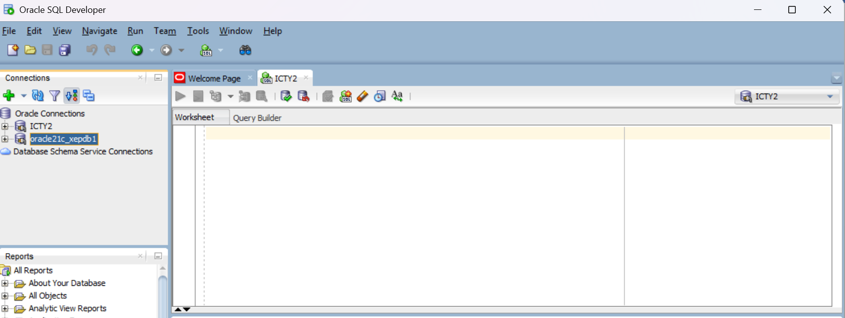
create a new user with the following details:
- Username: CEPIN
- Password: CEPIN123
Grant the user all necessary privileges (including CREATE SESSION).
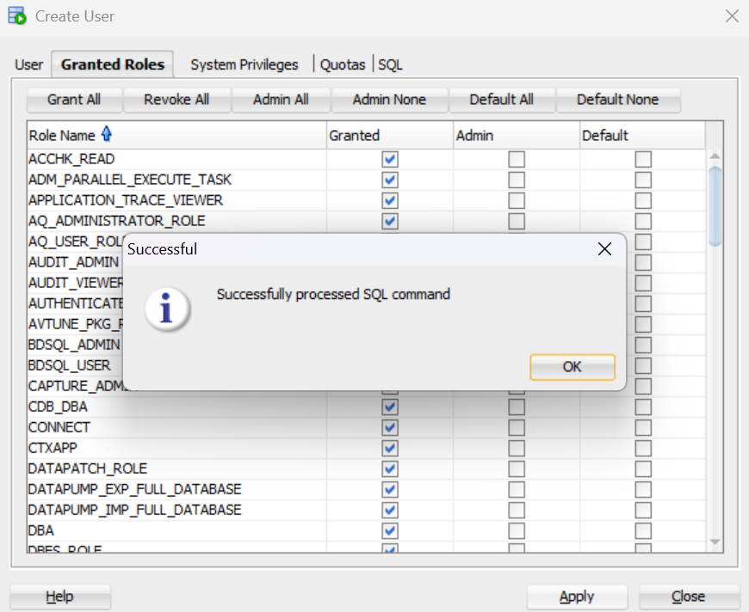
Unlock the account and set the password to never expire.
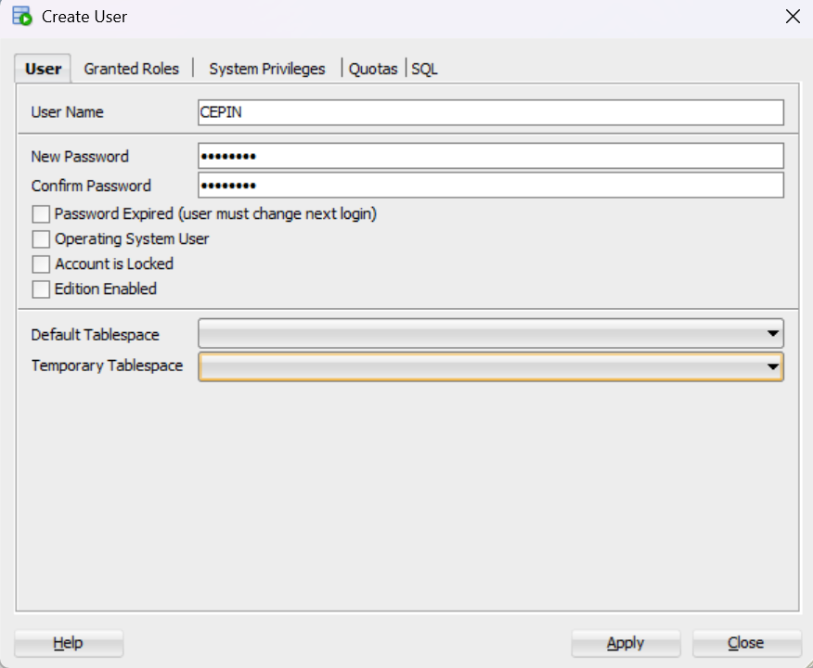

Question 2: Connect as User CEPIN
Connect to the database using the new connection ICTY2 with username CEPIN and password CEPIN123.
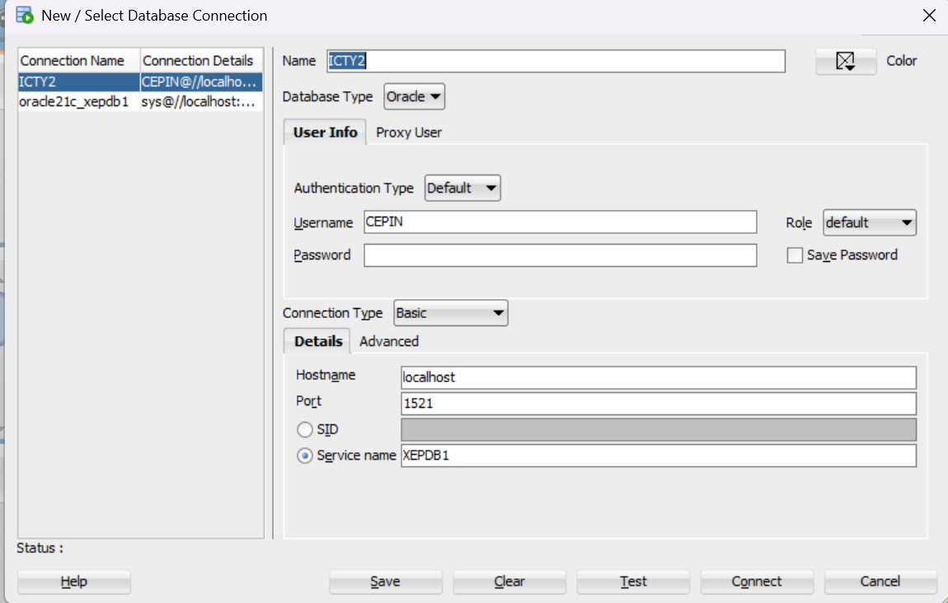
Question 3: Create a Table
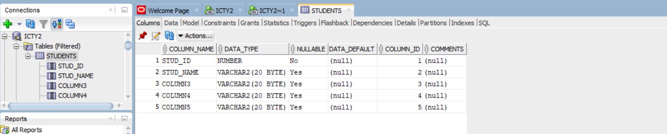
Create a table named STUDENTS with the following columns:
student_id | student_name | age | phone | location

Question 4: Insert Records
student_id | student_name | age | phone | location
1 | Alice Johnson | 32 | 5035483402 | kigali
2 | Bob Smith | 23 | 4056789453 | kigali
3 | Clara Williams | 43 | 2435678905 | kigali
4 | David Brown | 29 | 23456784568 | kigali
5 | Eva Davis | 30 | 43546784789 | kigali
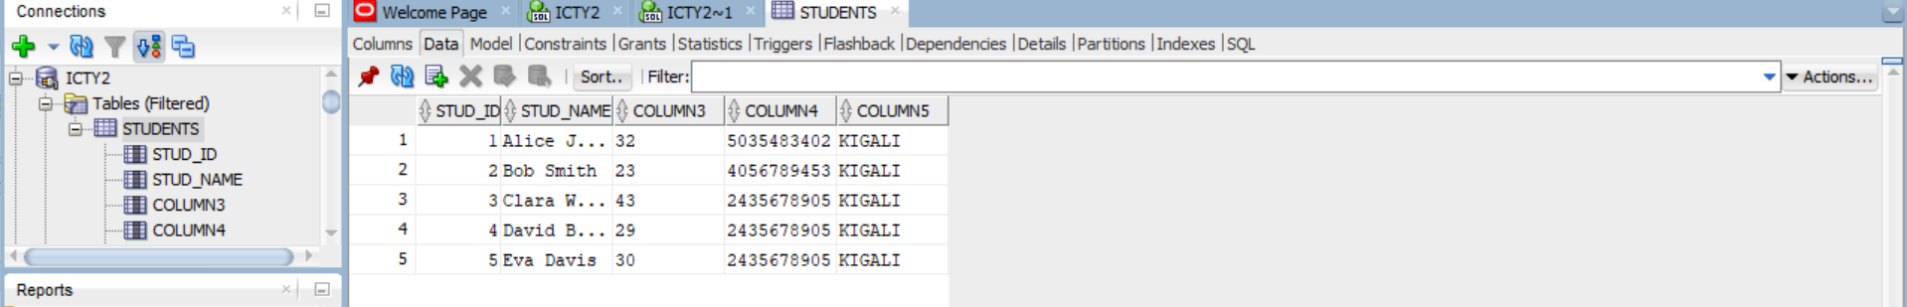
Question 5: Rename Column
Rename the column customer_id to id_number.
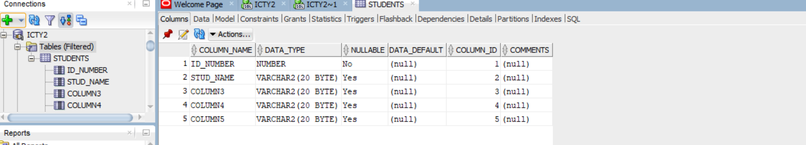
Question 6: Create an Index
Create an index called PROMOTION on the column customer_name.
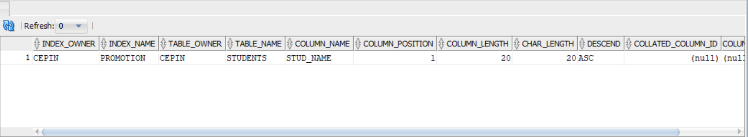
Question 7: Create a View
Create a view named STUDENTS_INFO that selects all records from the STUDENTS table.
